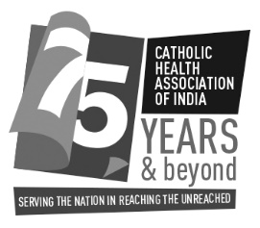
CHAI 75th ANNUAL GENERAL BODY MEETING &NATIONAL HEALTH CONVENTION
AT CHAI TRAINING CENTRE, KANDALKOYA, HYDERABAD, TELANGANA
28th & 29th SEPTEMBER 2018

REGISTRATION FORM

To,
The Catholic Health Association of India
157/6 | Staff Road | Gunrock Enclave | Secunderabad | Telangana | India 500 009
For Queries: nhc@chai-india.org
Or Call Ms.Theophine - 07893 966 203 or Office Landline: 040-27848457, 27848293

No | Delegate Name | Title/Designation | Congregation Name (if applicable) | Age | Sex | Arrival | Arrival | Departure | Departure
 |  |  |  |  |  | DATE | TIME | DATE | TIME
1
2

INSTITUTION DETAILS

Name: ……………………………………………………..

Place ……...………………………………………………

District ….…………………………………………………

State…………………………………………………………

Pin code: ………………………………………………….

Mobile No. ………………………………………..………

E-mail: ……………………………………………..……...

CHAI Membership No: ……………………………..

REGISTRATION FEE

Registration Fee: Rs.2000 /- per person (non-refundable) – for non-A/C, sharing rooms, including food, boarding and lodging.

Last date for Registration: 30th August, 2018

PAYMENT

DD / MO / Cheque  Demand Draft / MO / Cheque No...................dated......................  Drawn in favour of: The Catholic Health Association of India | Bank Transfer:  Name: The Catholic Health Association of India  Account No: 0413053000000002  Bank: South Indian Bank  Branch: Diamond Point  Place: Secunderabad  IFSC Code: SIBL0000413  UTR No........................................................................... Dated …….……...

Date: __________________________________________ Signature: _________________________________________

